Domain Driven Design (DDD)
14 June 2025
01:05 PM

Domain-Driven Design (DDD) Document – Industry-Grade
Project: Real-Time Fraud Detection & Notification System

1. Strategic Design
1.1 Core Domain
Fraud detection is the core domain and receives the highest attention. It includes high-complexity logic and key differentiators like rule-based engines and real-time analysis.
1.2 Supporting Subdomains
- Transaction Processing: Supports fraud detection with real-time data.
- User Management: Manages user identity and contact data.
- Notification Management: Sends alerts via third-party APIs.
1.3 Generic Subdomains
- Email/SMS API integration wrappers
- Logging, metrics, observability
- Identity and Access Management (IAM)

2. Bounded Contexts and Domains
Each context is developed, deployed, and scaled independently.
2.1 Transaction Context
Responsibility: Ingest and persist transactions.
- Entities:
  - Transaction { id, userId, amount, source, destination, timestamp, status }
  - User { id, name, phone, email, isActive }
- Aggregates:
  - UserAggregate: Validates active status, maintains transaction limits
- Services:
  - TransactionCommandService
  - TransactionQueryService
- Domain Events:
  - TransactionCreated
- Repositories:
  - TransactionRepository
  - UserRepository
- Communication: Kafka Producer → transactions topic

2.2 Fraud Detection Context
Responsibility: Evaluate transactions and detect anomalies in real time.
- Entities:
  - FraudRule { id, ruleName, threshold, enabled, ruleType }
  - FlaggedTransaction { id, transactionId, reason, severity, flaggedAt }
- Aggregates:
  - FraudEngineAggregate: Encapsulates all fraud rules
- Services:
  - FraudDetectionService
  - RuleEvaluatorService
- Domain Events:
  - FraudDetected
- Repositories:
  - FraudRuleRepository
  - FlaggedTransactionRepository
- Communication:
  - Kafka Consumer → transactions
  - Kafka Producer → flagged-transactions

2.3 Notification Context
Responsibility: Notify users via Email/SMS when fraud is detected.
- Entities:
  - Notification { id, userId, type, channel, content, status, sentAt }
- Aggregates:
  - NotificationAggregate: Holds all pending notifications
- Services:
  - NotificationOrchestrator
  - EmailGateway
  - SMSGateway
- Domain Events:
  - NotificationDispatched
- Repositories:
  - NotificationLogRepository
- Communication:
  - Kafka Consumer → flagged-transactions
  - External APIs → Twilio, SendGrid

2.4 Dashboard Context
Responsibility: Display real-time flagged alerts, transactions, and system stats.
- Views/Projections:
  - TransactionViewModel
  - FraudSummary
- Services:
  - TransactionQueryHandler
  - FlaggedTransactionQueryHandler
- Communication:
  - REST APIs (for admin dashboard)
  - WebSocket/SSE for real-time feeds

3. Shared Kernel
Modules used across contexts:
- DTOs (Data Transfer Objects)
- Kafka Configuration
- Spring Security (if secured endpoints are needed)
- API Clients (for Twilio, SendGrid)
- Custom Exception Handling
- Logging and Observability Layer (Micrometer + Prometheus)

4. Ubiquitous Language Glossary
Term | Meaning
Transaction | Any user-initiated debit/credit financial movement
Flagged Transaction | A transaction marked as potentially fraudulent
Fraud Rule | Business logic to identify a transaction as suspicious
Notification | Message sent to user via email or SMS
Event | A fact or action that has occurred in the system (immutable)

5. Context Map (High-Level)

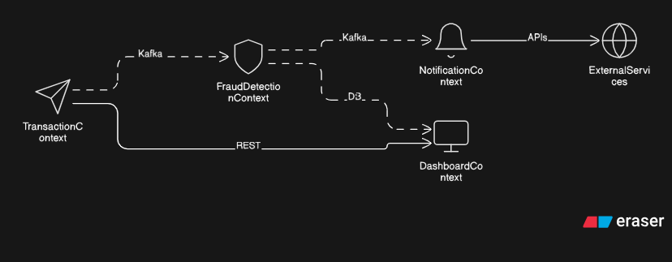

6. Technical Mapping (Optional)
Context | Tech Stack
All | Java, Spring Boot, Kafka
Dashboard | React + WebSocket/SSE
Data Store | PostgreSQL + JPA/Hibernate
Messaging | Apache Kafka
External API Layer | Twilio, SendGrid
Observability | Micrometer, Prometheus, Grafana

7. Domain Event Flow (Example)
Scenario: User makes a transaction → system detects fraud → sends alert
- TransactionCreated → Kafka topic transactions
- FraudDetectionService evaluates → raises FraudDetected
- NotificationOrchestrator sends email/SMS → logs NotificationDispatched

8. Summary
This industry-grade DDD outlines clearly defined bounded contexts that can evolve independently, communicate asynchronously, and adhere to high modularity. It allows scaling of fraud detection logic, integration with future ML components, and meets real-world expectations of distributed systems.

